Table of Contents

Chapter 1: Introduction 4

1.1 Overview 4

1.2 Background of the Project 4

1.3 Key Concepts 4

1.4 Methodology 5

1.5 Proposed Work 6

1.6 Summary 7

Chapter 2: Literature Review 8

2.1 Overview 8

2.2 Image Recognition 8

2.2.1 Face Recognition 8

2.2.2 Crop and Weeds Recognition 9

2.2.3 Factors Taken 9

2.3 Deep Learning Neural Network 10

2.4 Object detection 11

2.4.1 Faster R-CNN 11

2.4.2 YOLO 12

2.4.3 SSD 13

2.5 Summary 13

Chapter 3: Requirements Analysis 14

3.1 Overview 14

3.2 Functional Requirements 14

3.2.1 Recording 14

3.2.2 Object Detection 15

3.2.3 Sentence Processing 15

3.2.4 Translation 16

3.2.5 Synthesize Speech 16

3.3 Non-functional Requirements 17

3.3.1 Security 17

3.3.2 Performance 17

3.3.3 Usability 17

Chapter 4: Design 18

4.1 Overview 18

4.2 Functional Design 18

4.3 Interaction Design 19

4.3.1 Detection Interaction 19

4.3.2 Translation option interaction 20

4.4 Graphical Design 21

4.5 Summary 21

Chapter 5: Implementation 22

5.1 Overview 22

5.2 Interpretation of datasets 22

5.2.1 Initial research and experimentation on datasets 22

5.2.2 Creating custom data 23

5.2.3 Processing and splitting of dataset 24

5.3 Training the model 26

5.3.1 Importing the required libraries and files 27

5.3.2 Setting up training parameters and configurations 27

5.3.3 Beginning Model Training 30

5.4.4 Exporting the Model 30

5.4 Creating the Application 31

5.4.1 Designing the GUI 31

5.4.2 Sending Data for Predictions 33

5.4.3 Enabling translation 36

Chapter 6: Testing 37

6.1 Overview 37

6.2 Black Box Testing 37

6.3 White Box Testing 38

6.4 Model Evaluation 39

Chapter 7: Evaluation 40

7.1 Overview 40

7.2 Product Evaluation 40

7.2.1 Product Functionality 40

7.2.2 Strengths and Weaknesses 41

7.2.3 Mobile Implementation 42

7.3 Process Evaluation 42

7.3.1 Initiation Phase 42

7.3.2 Planning Phase 43

7.3.3 Analysis Phase 43

7.3.4 Implementation Phase 44

7.3.5 Testing Phase 44

7.3.6 Documentation Phase 45

Chapter 8: Conclusion and Recommendation 45

8.1 Conclusion 45

8.2 Recommendation 45

# Chapter 1: Introduction

## 1.1 Overview

This chapter will introduce the background and concepts regarding the project. That includes proposed work, expectations and features of the final product. Besides that, the methodology and software tools adopted will also be discussed here.

## 1.2 Background of the Project

Transign, an artificial intelligence-based real-time sign language to speech translation application, has the main features of detecting hand signs and then converting it them to speech.

This project aims to ease the difficulty of communication for deaf/mute people in everyday life as the skillset for understanding sign language is a skill rarely found among people within society in the current times. ASL (American Sign Language) will be the go-to sign language for this project due to its popularity. The project will go through a few phases to accomplish this objective. Firstly, custom data of hand signs are produced through a webcam. Following that, the dataset is cleaned and processed before it is fed to the model for training. Once a feasible model has been produced, the inference will go through a few confidence tests before it is passed as legible sign language and then converted to text for speech synthesizing. The resulting translation can also be translated to other spoken languages to further bridge the gap of communication between deaf/mute people and other ethnics around the world.

## 1.3 Key Concepts

At the base of this system is the hardware which will be the mobile handheld devices used daily by almost everyone known as smartphones. A device can be considered a smartphone when it has the processing power and memory to run applications, make phone calls and text messages, access to the internet, sound input and output, and lastly camera capabilities(*What is a smartphone? | Digital Unite*, no date).

With that said, the system will be using Android-based smartphones. Android is an operating system for smartphones developed by Google and is the operating system of more than 70% mobile handheld devices worldwide to date(*Mobile Operating System Market Share Worldwide | StatCounter Global Stats*, no date).

Moving along, a few keywords must be known that will be used throughout this proposal. The first one being **image processing.** The definition of image processing is to manipulate images by processing it through computers(Young *et al.*, 2004). Images can be broken down into a matrix of precise numbers that can be quantized and manipulated to do tasks such as image enhancement, restoration, and analysis(da Silva and Mendonça, 2005). The system will be mainly focused on the enhancement and analysis aspect of image processing to process then extract useful data from the video feedback given through the smartphone camera.

Besides that is **machine learning,** itis the core of what people of the current era knows as artificial intelligence(Shalev-Shwartz and Ben-David, 2014). It has the power to learn autonomously without any manipulation from a human being through the data fed into it to look for similarities or patterns through computing power and models made by human beings. It uses what it has learned to make decisions when provided input and output a desirable outcome(Decencière *et al.*, 2013).

Moving along is **deep learning**, a subset of machine learning algorithms mainly inspired by the function of a human brain called artificial neural networks(Socher, Bengio and Manning, 2012). Deep learning models achieve immaculate accuracy and speed, sometimes better than human-levels when it comes to classification tasks directly from images, text, or sound. These models train through enormous sets of labeled data and neural network architectures containing many layers similar to a human brain(Perez and Wang, 2017).

Last of all we have **real-time object recognition,** which has the aim of producing decisions on the spot when given live data on-site like video from a camera feed(Chadalawada, no date). It requires a robust deep learning model that can process information as quickly and as accurately as possible due to the time-sensitive nature of tasks object recognition is used for such as autopilot systems(Gavrila and Philomin, 1999).

## 1.4 Methodology

For this system, the Prototyping Model is the methodology the system’s development will follow. This methodology is the most suitable for this project as the ideas behind this system are fairly new and never done before so requirements for it may change as functions are developed(Al-Husseini and Obaid, 2018).

Firstly, the system’s requirements will be analyzed by doing more research on what deaf and mute people would like to see in an application that will mainly affect them or be used by them. Not only that, the frameworks and models practical usefulness will also be analyzed in this phase.

After that, once all the requirements have been detailed and documented, a feasibility study will be done to see whether the project is feasible to be developed. An example of this is checking what Android devices have adequate resources to run this system once it is developed.

Continuing on, a feasibility study will be conducted when the first design of the system is created. This design is considered the first prototype and once it is created, it will go through an evaluation to see what other requirements or enhancements should be done. This will repeat until a satisfying product is created hence the name prototyping. The first prototype may be functional and able to recognize sign gestures but does not have a friendly UI to be used. It will go through the second prototyping to redesign the UI with its sign gesture recognition functions and be reviewed again(Carr, 1998).

Lastly, once a satisfying prototype has been created, it will go through final testing and maintenance before becoming a finalized product. This is where all the test code and straggling bugs are cleaned up so that the final product used does not have any problems(‘SDLC - Software Prototype Model’, no date).

## 1.5 Proposed Work

The proposed system is to create a mobile application in Android that will be able to recognize sign language gestures and translate it into speech. This application is mainly targeted to assist deaf and/or mute people with communicating with the general society when text or writing does not suffice.

As its nature states, this system will focus on Android handheld devices. This means that the application will only be able to run on devices that use the Android operating system. The device must have a camera which will not be a problem as the majority of Android devices nowadays come equipped with one.

The system will be designed with Kotlin, a language being pushed by the developers of Android, Google, as the new mainstay for Android application development(*Kotlin and Android  |  Android Developers*, no date). It will work in tandem with libraries such as OpenCV, TensorFlow, and Keras to recognize objects within the live video feed of the camera and train the data into suitable models.

The system will not have any processes that run in the background and will only be an application that can be run on the main thread. This will comfort the user’s privacy is maintained as the system does not have anything to do if it is not currently being used.

As far as cloud connectivity goes, the requirement for it will be decided as development goes during the prototyping. Whether the model will perform better as a live service on the cloud or run locally on the device will be analyzed and evaluated during the developing phase.

The system will have its model created by TensorFlow and Keras and then trained with data found on the web or data given to it through the OpenCV controlled camera video input from the Android device(Zebin, 2017). The system will learn to recognize the gestures through the model and link them to the correct translations.

There are a lot of basic American Sign Language datasets that can be found on Kaggle, an open-source dataset website, containing the datasets such as the alphabet and digit gestures which will become the foundation of the data used to train the model here(*Interpret Sign Language with Deep Learning*, no date). As for the image recognition techniques, TensorFlow has APIs with trained models to recognize objects and classify them into objects. For this system, once hands have been recognized then it can go deeper and look for what gestures are being performed to recognize what gestures are being made.

## 1.6 Summary

After identifying the aims and objectives for this proposed system, it is concluded that this system requires more research before implementation. All the other areas of research will be discussed in next chapters with proper justifications and examples.

# Chapter 2: Literature Review

## 2.1 Overview

In this chapter, three areas of research will be discussed that includes image recognition, machine learning and object detection. This analysis was aimed to help in studying all the methodology and complexity in the implementation of the proposed system. Each of them will be supported by at least two existing system literature.

## 2.2 Image Recognition

The purpose of this study is to analyse all the existing image recognition projects to get some understanding and insights about their approach and methodology.

### 2.2.1 Face Recognition

Another important area of research in image recognition is face detection system. The threshold function for a system will extract the information from the human face. The first existing system in this field was by Fares Jalled in 2017 who build a face recognition system using EigenFace which discriminating image input into multiple classes for person identification. The researcher’s proposed system structure starts from the image input to the pre-processing process of the image. In the image pre-processing stage, the image resolution, environment elimination, image rotation as well as illumination to the image were taken care of before the next step, feature extraction (Jalled, 2017). In the feature extraction, the system will retrieve all the distinctive elements from a person's face for classification purpose. The classification purpose will classify the person by their name and features on their face through the database. Another face recognition project considered for this area was from Priyanka Wagh and her colleague in 2017. This proposed system was aimed to use face recognition to help in taking attendance. This system achieves face recognition by setting up a static camera where the entire class is covered to periodically take a photo. The taken photos were converted to a grayscale image with histogram equalization to improve the contrast in the image (Wagh et al., 2015). For the student recognition in the classroom, Viola and Jones framework were used. Each recorded face was tested through EigenFace and Principal Component Analysis (PCA) for random value reduction as EigenFace often maximize variation so with PCA it helps the system to combine the variations based on a specific principle (Wagh et al., 2015).

### 2.2.2 Crop and Weeds Recognition

In the 1990s, a research was conducted in conjunction between related agricultural departments from the McGill University and Cornell University which was built on the rapid improvement of machine vision and image processing technology at the time to distinguish weeds from actual crops by leveraging the power of artificial neural networks (ANNs) (YANG, et al., 2000). The images were taken in bird’s-eye view at random locations within the fields of the in campus farms of McGill University with slightly varied zooms but similar aspect ratios. For training and testing purposes, common weeds were put into one category and separated from the target crop which in this case were corn plants. The images would be processed into 8-bit color bitmaps and then further cropped into 100x100 pixels from the original image’s resolution. This ensured that the crops and weeds were properly seen in each cropped section while optimizing it for processing within the ANN where PC memory was inadequate (YANG, et al., 2000). The images would then be fed into the ANN where the color index of a cluster of pixels would go through the processing elements (PEs) of the ANN and return 1 or 0s depending on whether a crop or weed was predicted for that cluster. The results from all cluster predictions would then be gathered and inferenced from a confidence of 0…1 to predict whether the plant seen within the cropped image is a crop or weed. Multiple configurations of PEs were tested for the recognition of crop and weeds which returned a noteworthy result. The ANN’s prediction result of weeds accuracy rose from 40 to 50% to 70 to 80% when 200 PEs instead of 160 were incorporated to its hidden layer but the accuracy for the prediction of corn plants decreased when more PEs were added onto the ANN’s hidden layer compared to the previous 200 PEs (YANG, et al., 2000).

### 2.2.3 Factors Taken

The feature extraction method used in the face recognition research paper will be used in this project as it is proven to work well with human skin and can easily find simpler limbs such as hands when it can detect and classify faces easily. As for the weeds and crops, the method of grid cell inferencing will be used in conjunction with the neural network architecture which will be talked about in the next section.

## 2.3 Deep Learning Neural Network

The proposed project uses a specific neural network architecture specifically known as convolutional neural network (CNN).

CNNs primarily focus on input made up of images, ensuring that the architecture is set up best suited for dealing with that type of data. The reason for this is a key difference between CNNs and artificial neural networks (ANNs). The neurons within the layers of CNNs are organized in three dimensions comprising of spatial attributes such as height, width and depth (O'Shea & Nash, 2015). The depth mentioned in this case does not refer to the outstanding number of layers in the ANN but the third dimension of an activation volume. Compared to usual ANNs, the neurons within any given layer in the CNN only connect to a small region of the layer before it.

CNNs are made up of three forms of layers. These layers are known as convolutional layers, pooling layers, and fully-connected layers. A CNN architecture is formed when these layers are stacked together (O'Shea & Nash, 2015).

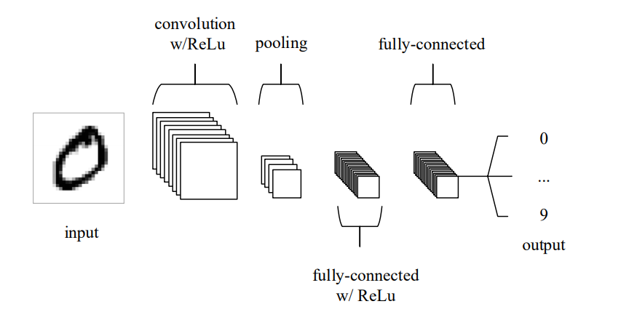

Figure 1 Simple CNN architecture (O'Shea & Nash, 2015)

Seen in figure 1 above is a simple CNN architecture made of only 5 layers for MNIST classification. The input layer contains the pixel values of the image fed into the CNN. Following that, the convolutional layer produces the output of neurons that are joined to local regions of the input through calculating the scalar product between their weights and the region joined to the input volume. The rectified linear unit (ReLu) applies an ‘elementwise’ activation to the output produced by the previous layer. The pooling layer has the role of downsampling along the input’s spatial dimensionality, lowering the number of parameters within that activation. Lastly, the fully-connected layers perform similar roles as normal ANNs to produce class scores for classification (O'Shea & Nash, 2015).

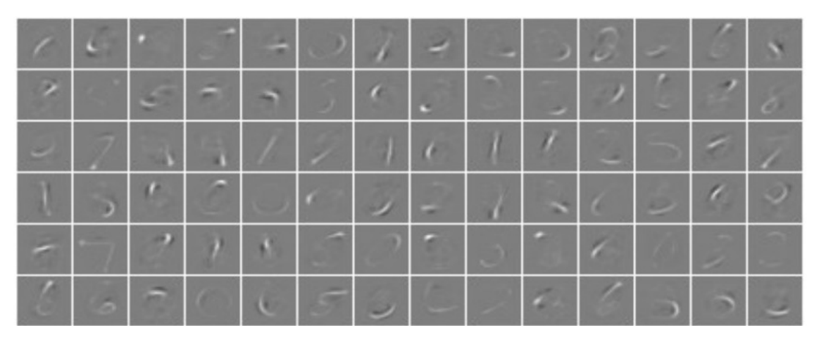

Figure 2 Activations from convolutional layer (O'Shea & Nash, 2015)

As seen in figure 2 above, the network picks up on unique characteristics of specific numeric digits from MNIST’s database of handwritten digits.

## 2.4 Object detection

For object detection, there are a few algorithms that must be discussed and compared that are based on the CNN architecture mentioned in the previous subtopic. These algorithms will be discussed in the subtopic below.

### 2.4.1 Faster R-CNN

The R-CNN technique trains CNN end-to-end to do classification for proposal regions into object background or categories. R-CNN mostly act as a classifier, and the object bounds cannot not be predicted. The performance of the region proposal module defines the accuracy. Pierre Sermanet and his team proposed a paper in 2013 under the title of “OverFeat: Integrated Recognition, Localization and Detection using Convolutional Networks” which shows the ways of using deep networks for predicting object bounding boxes (Sermanet et al., 2013). In the OverFeat method, a fully-connected layer is trained to predict the coordinates of the box for the localisation task that consider a single object. Then, the fully-connected layer is turned into a convolutional layer for multiple class object detection (Sermanet et al., 2013). Figure 3 shows the architecture of Faster R-CNN which is a single, unified network for object detection.

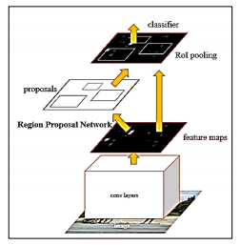

Figure 3 architecture of Faster R-CNN (Sermanet et al., 2013)

Fast R-CNN implement end-to-end detector training on shared convolutional features and display decent accuracy and speed. On the other hand, R-CNN fails to do real time detection because of its two step architecture.

### 2.4.2 YOLO

YOLO stands for “You only look once”. According to Redmon (2016), it is an object detection algorithm that runs quicker than R-CNN because of its simpler architecture. Classification and bounding box regression will be done at the same time. Figure 4 shows how YOLO detection system works.

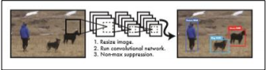

Figure 4 YOLO Detection

A single convolutional network predicts several bounding boxes and class probabilities for those boxes simultaneously. YOLO trains on full images and the detection performance will be optimised directly. This ensures YOLO to run extremely fast, hence producing real-time predictions.

### 2.4.3 SSD

Lastly, we have SSD which stands for “Single shot detection”. SSD is another algorithm with similar performance metrics to YOLO where SSD wins in overall accuracy and speed but loses out in number of true positives and recall values (Morera, et al., 2020).

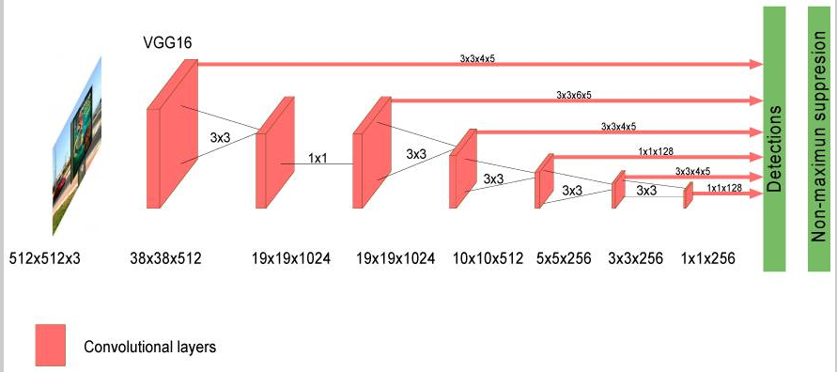

Figure 5 SSD Algorithm (Morera, et al., 2020)

As seen in figure 5 above, a CNN based on SSD defines a domain of anchor boxes with varying sizes and aspect ratios at multiple locations of an image. The detection box prediction is then done based on these references. The SSD algorithm does not resample features for bounding box hypotheses unlike R-CNN and is compatible with real-time applications.

## 2.5 Summary

In conclusion, the CNN architecture is chosen due to its performance and compatibility with processing image data. Moving on, the CNN-based SSD algorithm will be used due to the cost-performance ratio in terms of computing resources, making it suitable for the purpose of the project without sacrificing the accuracy of the results produced. As the CNN-based SSD model only needs to check the data once and then process it with different layers in different grid setups, accuracy is still maintained on objects that do not require immense detail while being efficient on processing power which is suitable for this project.

# Chapter 3: Requirements Analysis

## 3.1 Overview

After completing all the research on relevant literatures, main functionalities of the system will be discussed in this chapter though a conceptual model. After discussing the conceptual model, commentary on chosen methods will be done in terms of functional and non-functional requirements to further the research.

## 3.2 Functional Requirements

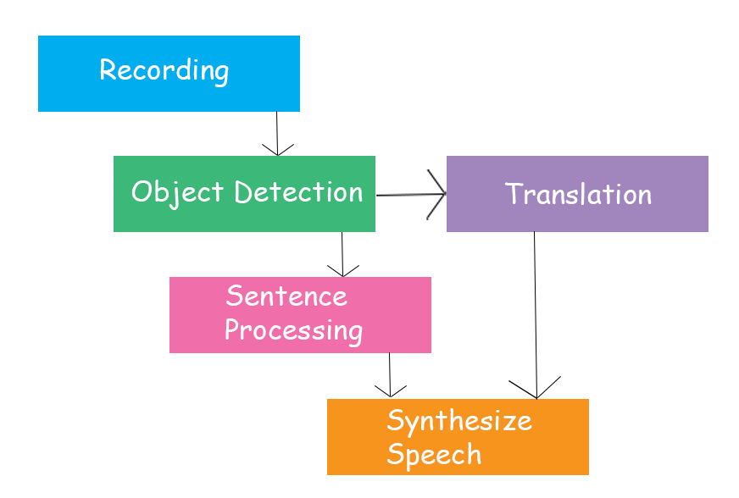

Figure 6 Transign functional requirements

### 3.2.1 Recording

As seen in figure 6 above, there are 5 functional requirements within this project. The first requirement is the recording function. The recording function is essential as it is the method to gather image data for detection in real time. This function will leverage the OpenCV application programming interface (API) to gather data through a recording hardware of the user’s choice. The data will be gathered at a rate of 30 frames-per-second (FPS) and 800 by 600 pixel resolution to satisfy a few conditions of the application. These parameters ensure that none of the peripheral background or surroundings are recorded as they are not relevant to the required input, ensuring accuracy with the user as the main focus in the center of the image data gathered. Not only that, less memory resources are required without impacting prediction results when 30FPS is used instead of 60FPS. Lastly, the resolution specified satisfies the aspect ratio of data that will be used to train the model, ensuring that the image is not distorted when undergoing pre-processing phase before being sent into the model.

### 3.2.2 Object Detection

Following that is the object detection function. Once the image data has been recorded, it will then be processed to fit the parameters of the model. As mentioned in the previous chapter, the object detection will use the CNN architecture with the SSD algorithm. The image data will be divided into grid cells where each cell is responsible for inferencing classes and boxes within its boundary. If an object overlaps multiple regions at once, pre-defined anchor boxes will kick in to supplement the prediction of the objects within the image (Developers, n.d.).

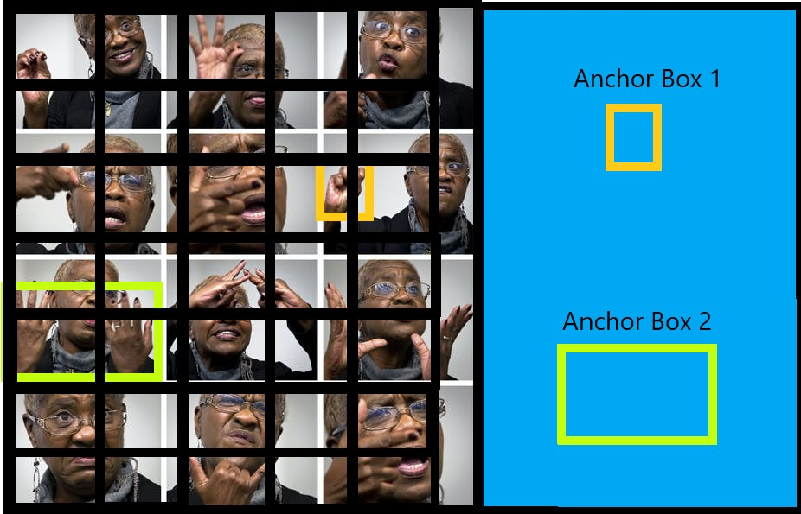

Figure 7 Grid cells and anchor boxes

### 3.2.3 Sentence Processing

Next up is the functional requirement called sentence processing. In all sign languages, hand signs usually convey meaning but don’t join up to complete sentences. For example, sentence helpers such as “is” or “are” aren’t present in the ASL dictionary. With that, converted sentences from hand signs will not sound legible in a conversational environment. Sentences converted from the hand signs have to go through sentence processing so that it will sound normal when used in a conversation context.

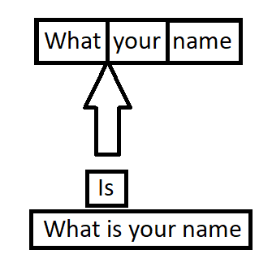

Figure Sentence processing visualization

### 3.2.4 Translation

Another requirement is the translation function. The Transign application allows the user proficient in only one sign language to communicate with foreign people within or outside of their local country. This function will use the Google Translate API to facilitate its translation as it is one of the most readily available and competent translation APIs in the market.

### 3.2.5 Synthesize Speech

Lastly, we have the function to synthesize speech. Once all the translation or sentence processing has been completed, the output from that will be synthesized into a voice that is relevant to the chosen language. For example, an English speaking voice may not be able to pronounce Japanese words properly and thus will require some additional work to produce legible speech. This will require additional Windows internal speech packs to be installed.

## 3.3 Non-functional Requirements

### 3.3.1 Security

Security is a factor of importance in any application. Hence, this application does not store any of the user’s image data locally or virtually and will be dumped once users have finished their usage purposes. Even though Internet access is required for some functions to work, no data is sent out of the application’s memory scope.

### 3.3.2 Performance

Transign will be able to perform in any device with decent processing power as long as it has hardware to record image data and output sound. As no file writing or uploading tasks are done, processing power requirements are kept to a minimum and the only load observed will be from reading and processing image data from the recording hardware.

### 3.3.3 Usability

Usability is another factor to take note of within this project. There will be no login requirements which means that users can directly dive into using the system. Not only that, the Graphical User Interface(GUI) is not complex and does not show any technical jargon that would not be understandable by the layman user. The application is also usable out of the box for its basic functions and does not require additional external modules.

# Chapter 4: Design

## 4.1 Overview

In this chapter, system design of this proposed system will be discussed. Furthermore, this chapter will also cover the design models such as Unified Modelling Language (UML) diagrams such as use case diagram, class diagram, sequence diagram and storyboard of the application.

## 4.2 Functional Design

Table Use case descriptions

|  |  |  |  |
| --- | --- | --- | --- |
| **Use case** | **Pre-conditions** | **Description** | **Flow of events** |
| Open Camera | GUI Initialized | Start the camera stream with OpenCV | 1. The GUI loads  2. The user clicks on the start button  3. the camera frame begins streaming |
| Text-to-Speech | Text inferenced | Takes the results outputted from the model and converts it to speech | 1. The model outputs its predictions  2. The predictions are displayed on screen  3. The predictions concurrently get synthesized into speech and played. |
| Detect Sign Language | Camera stream started | Takes the camera stream data and sends it for predictions | 1. User begins doing hand signs  2. The hand sign frames are taken and sent to the model for detection  3. The model begins predicting |
| Translation | Internet access,  User has it enabled | Runs translations on the predictions to other languages. | 1. The user enables it on the GUI  2. The detected hand signs are converted to English and then sent for translation  3. Google Translate API returns translated results. |
| Internet Checking | GUI Initialized | Checks user’s device for internet connection | 1. The GUI loads  2. The user clicks on the Internet check button  3. A message box pops up to lock the UI  4. A ping is sent to Google’s server for response. |

Looking back at the previous chapter, there were in total 5 functional requirements. For the recording function, the Open Camera use case is linked to this as it will be how the image data is recorded. As for object detection, the Detect Sign Language use case is where the bulk of the work will be done for this function as it is the use case where the model will be situated in doing predictions. Following that, Text-to-Speech will cover the sentence processing and synthesize speech requirement. Text-to-Speech is where all the adjustments to the predictions will be done through an English dictionary to generate a legible speaking sentence. After that, the speech will be synthesized and then played in real time. Lastly, the translation requirement is covered by the translation and internet checking use case. Internet needs to be confirmed before translation can run and this is done by the internet checking use case. Following that, the translation can be enabled and will be done with the help of the Google Translate API. The use case diagram for this can be found in the appendix.

## 4.3 Interaction Design

In the interaction design there will be two figures to present the flow of the system’s function. This section will describe how the system’s internal functions will interact with each other within the system.

### 4.3.1 Detection Interaction

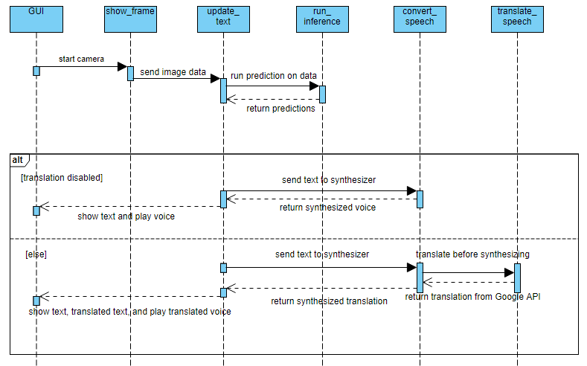

Figure 10 Detection Sequence Diagram

In figure 9, the interaction will begin at the GUI message. Once the user has a clicked the button to start the camera, the show_frame message will start up and begin sending image data to the update_text message. After that, the update_text message will call the run_inference message to begin predictions on the image data and wait for its predictions to be sent back. If the user did not enable translation, the update_text message will send the predictions to the convert_speech message where the synthesized speech will be directly sent back to the update_text message and back to the GUI message to be displayed and played. Otherwise, the predictions will be sent to the translate_speech message first before being synthesized into its destination language’s suitable voice.

### 4.3.2 Translation option interaction

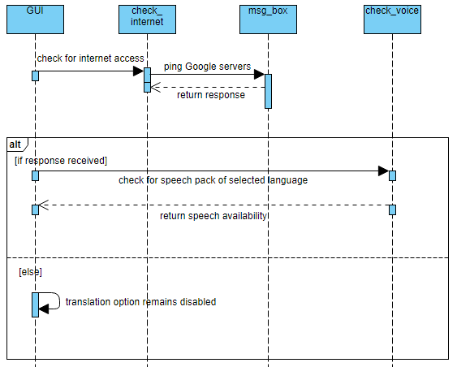

Figure 11 Translate option sequence diagram

In the translation option’s interaction, the flow will once again begin at the GUI message and moves on to the check_internet message as the user has to confirm that they have internet access first before they can enable translation. A dialog box will pop-up to let the user know that internet access is being verified while a quick ping to Google’s server is being done. This will all be done by the msg_box message. If a response to the server has been received, the check_voice message will then check if the language selected has a speech pack installed locally and display the results on the GUI. Otherwise, the translation option remains disabled on the GUI.

## 4.4 Graphical Design

The application will have a simple interface that can be easily understood within a few minutes of first opening the application. It will consist of a few text boxes to display translated and detected text, a frame to show the user as their hand signs are being detected, and lastly a few buttons to initialize the features of the application. A simple mock design can be seen in the figure below.

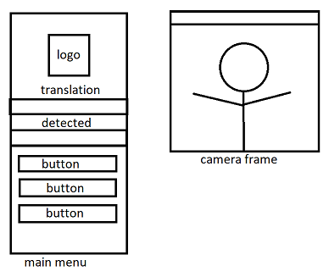

Figure Mock design

## 4.5 Summary

After designing all the UML diagrams, a clearer picture can be seen to develop the proposed system. In next chapter, the implementation of the system will be discussed.

# Chapter 5: Implementation

## 5.1 Overview

In this chapter, the implementations that were implemented in this project will be discussed which covers the methods and techniques used for the implementation and also the justification on the main functionalities along with code snippets.

## 5.2 Interpretation of datasets

### 5.2.1 Initial research and experimentation on datasets

In the initial research on datasets, a lot of data was found for sign languages in ASL on public sources such as Kaggle. An example of the data can be seen in figure 11 below.

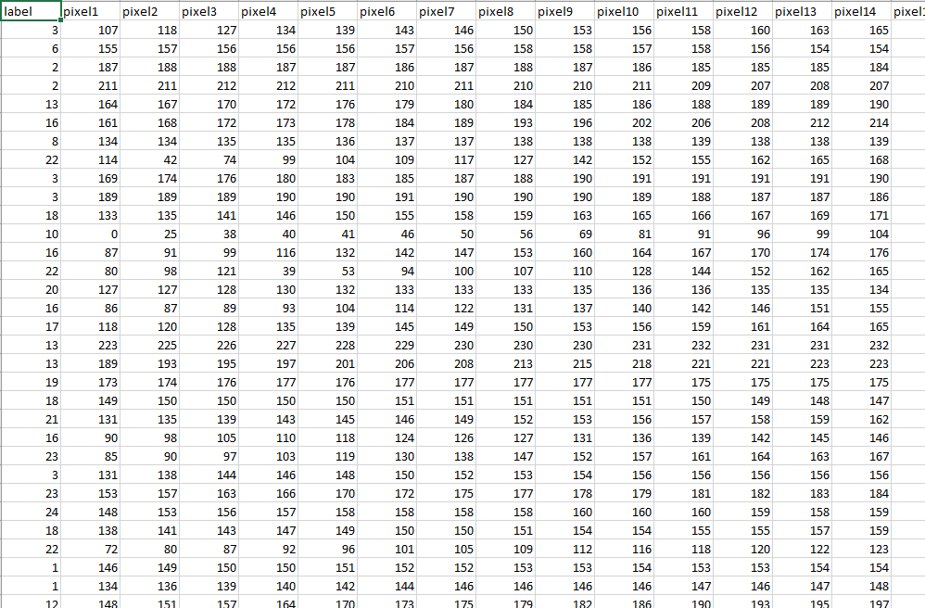

Figure 13 Example data

These were all data of alphabet hand signs and initially used to train a model with good results before encountering a major problem. After further research on existing data on public sources, there were no datasets found for complete words within ASL. Long consideration was made at this point of developing the application due to the imbalance in size of creating custom data compared to using existing data. In the end, creating custom data instead of using existing datasets was opted for due to the importance of complete words.

### 5.2.2 Creating custom data

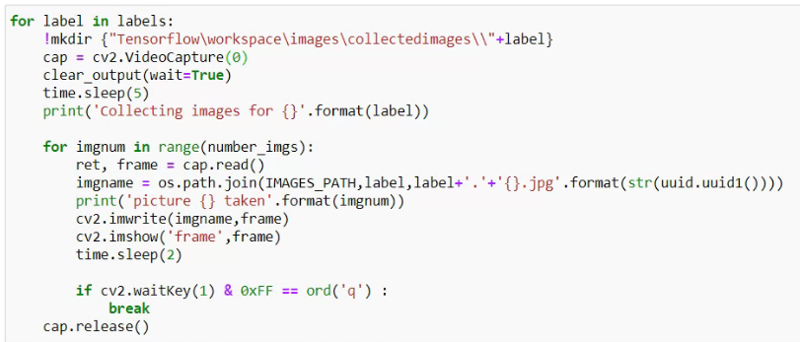

Figure 14 Code snippet to gather data

Once the decision was made, custom data was gathered using a webcam on a laptop through the code snippet above. The code snippet mainly used OpenCV’s Python API to load up the webcam, capture the images and written to indexed folders with categorized names through the built-in OS library.

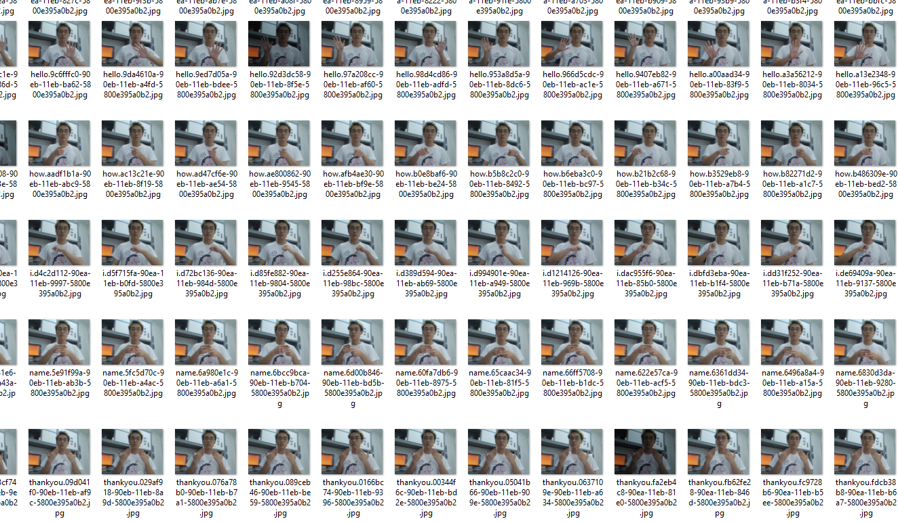

Figure 15 Custom dataset

In figure 13, the custom data can be seen gathered and contains around 9 classes with around 45 images gathered to represent each class, totaling up to slightly above 400 images.

### 5.2.3 Processing and splitting of dataset

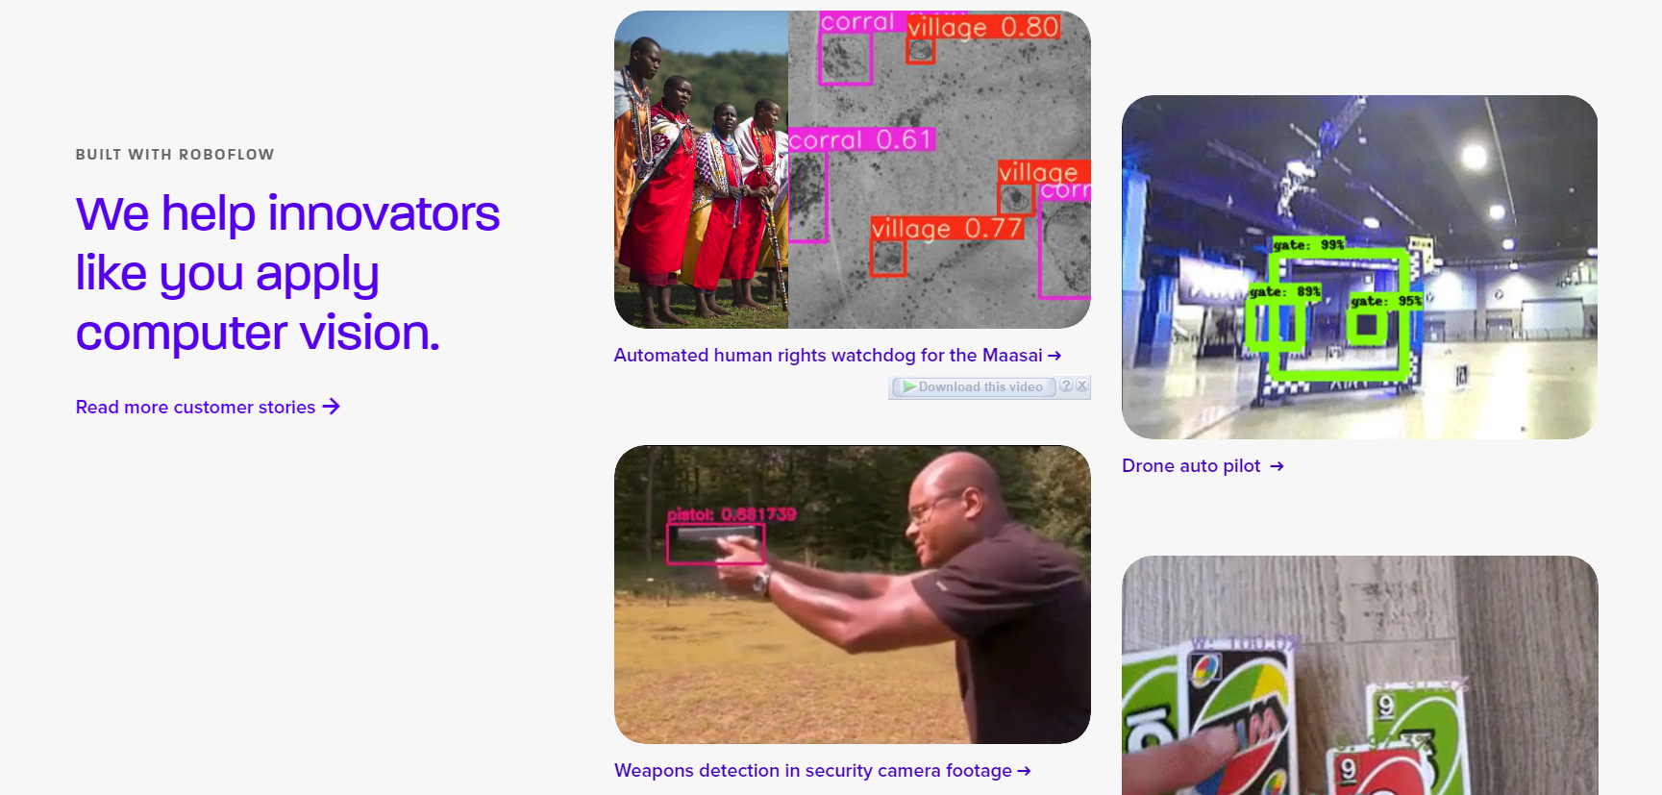

Figure 16 Robowflow home page

For the processing and splitting of the dataset, a third-party helper site was used to facilitate the processing of the dataset. The site is called Roboflow and contains many helpful tools such as annotating, labelling, organizing, processing, etc. for building computer vision projects.

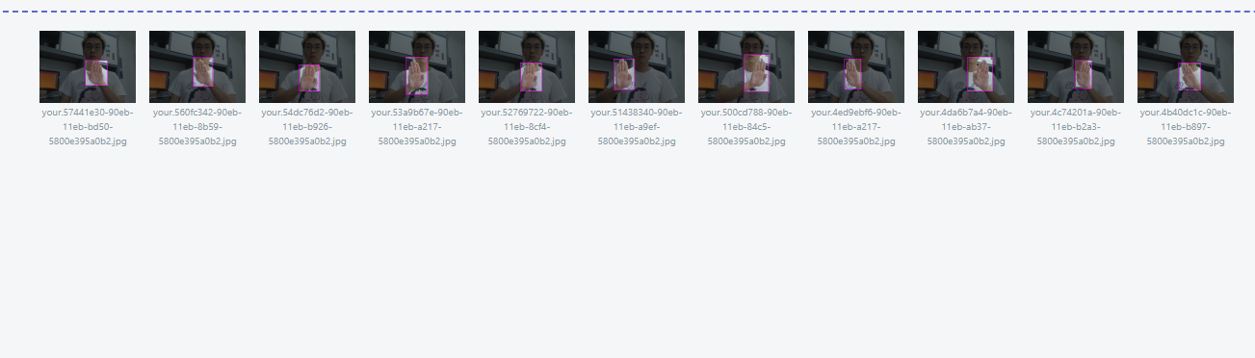

Figure 17 Data organisation in Roboflow

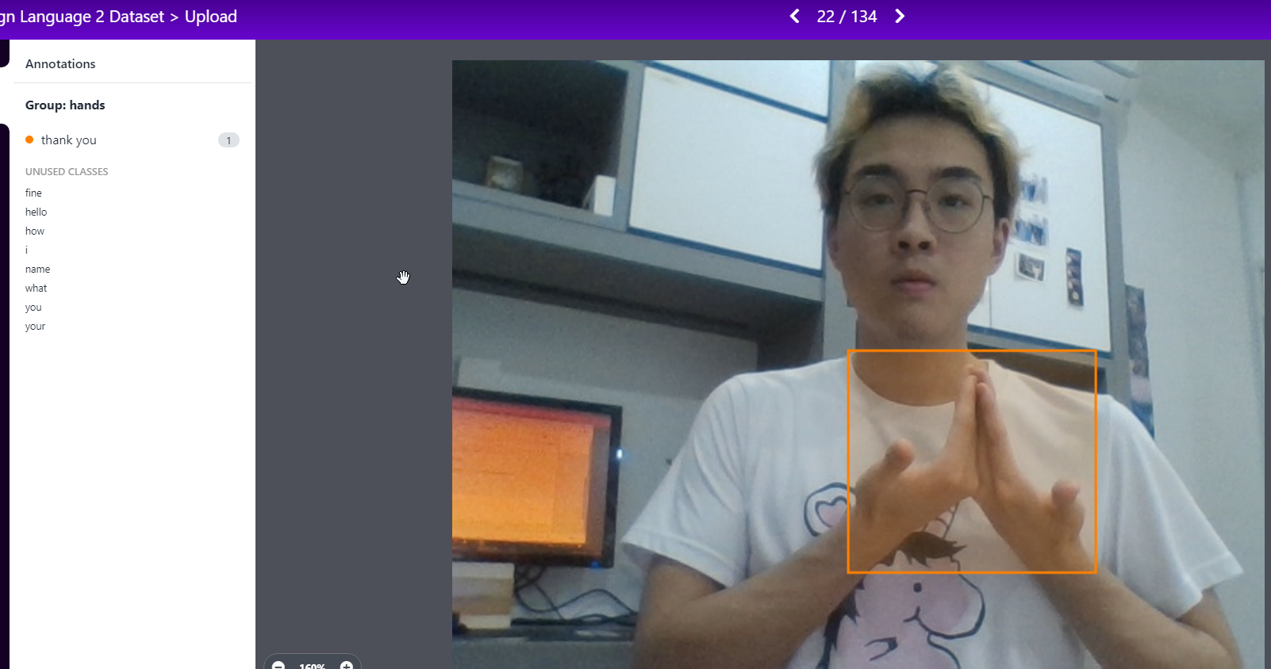

Figure 18 Image annotation tools in Roboflow

As seen in figure 15 and 16 above, Roboflow provides simple and easy to use tools for preparing datasets before moving on to the processing of the data which will be touched on more next.

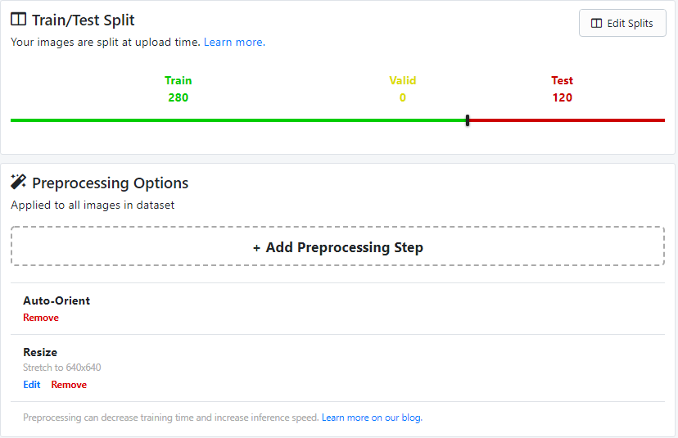

Figure 19 Pre-processing and data splitting

Roboflow also provided the ease of splitting up your dataset and pre-processing steps. In figure 17, resizing and cropping options were used to get an aspect ratio suitable to be used for the training of the model later on. The ratio used in splitting the data was a 7:3 ratio where 70% would be used for training the model while 30% would be used for evaluation during the training. Roboflow also provides the tools to do augmentations on images but those provided sub-optimal results which would be talked about later.

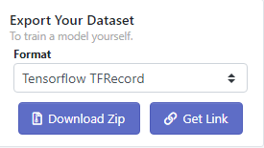

Figure 20 Exporting processed data

Once satisfied with the processing and splitting of the data, Roboflow also helps with exporting the dataset in your preferred format. Since the model training will be done through the Tensorflow API, the TFRecord format was chosen as the export format. As seen in figure 18 above, the dataset can also be downloaded locally to the device or through a link that provides a curl command with a unique token to the dataset that can be used to do training on the cloud.

## 5.3 Training the model

Model training will be done through Tensorflow, specifically the Tensorflow Object Detection API. There are a variety of models within the Tensorflow’s Object Detection model zoo. As mentioned before in the literature review and design chapters, this application will use the “SSD MobileNet V2” which is built following the CNN architecture with SSD algorithm at its base. The model training will also be done on the cloud through Google’s Colab as it provides top end computing power for free in a limited time period which will suffice for this project’s training purposes.

### 5.3.1 Importing the required libraries and files

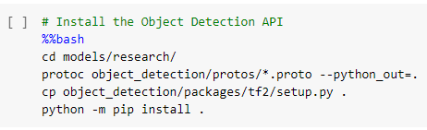

Figure 21 Importing Tensorflow libraries

To train the model, the Tensorflow model repository has to first be downloaded from their github website. After downloading, the protos files have to be compiled with the Protocol Buffer library and then install all the relevant libraries with the setup file inside the respository as seen in figure 19.

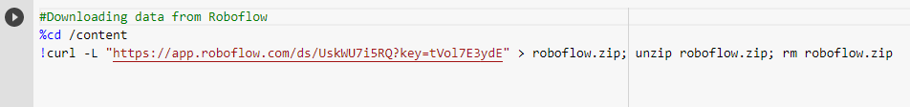

Figure 22 Importing data from Roboflow

The data that was processed and split in Roboflow now needs to be imported into the cloud and is done as seen in figure 20. As the token is unique to every user, it has been hidden here so that data is not leaked.

### 5.3.2 Setting up training parameters and configurations

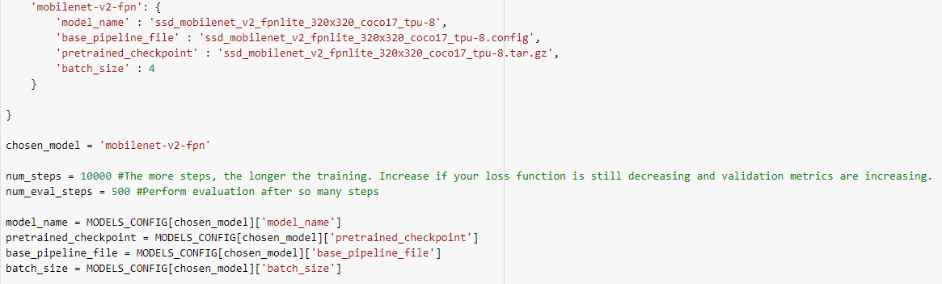

Figure 23 Parameters

In figure 21, the variables are setup with the appropriate names and values to make inputting easier later on as the names of the model files and checkpoints are long.

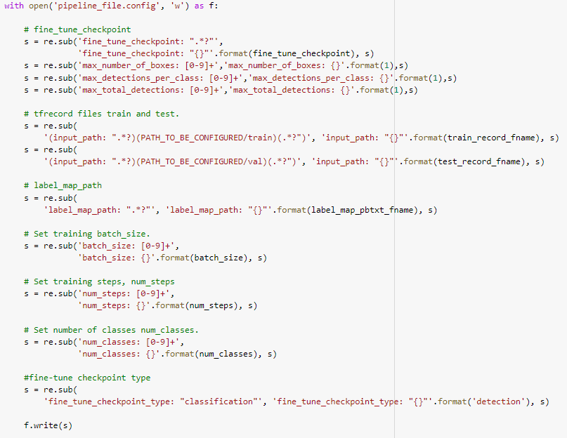

Figure 24 Setting up configurations

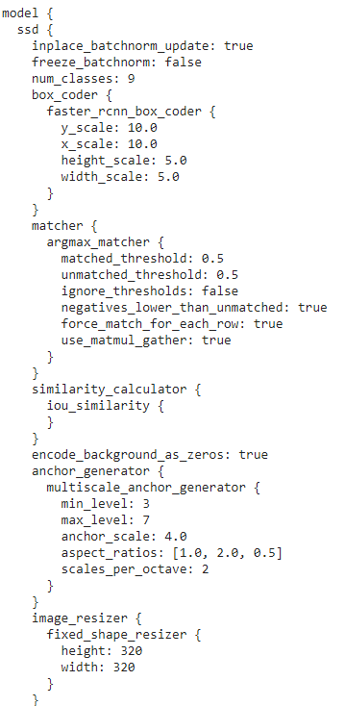

Figure 25 Snippet of the final configuration

Next up is editing the configurations for the model training. The base model comes with a template configuration file but it needs to be changed so that it is suitable for this application’s purposes. In figure 22, there is an example of some of the parameters being changed to suit this project’s purposes.

### 5.3.3 Beginning Model Training

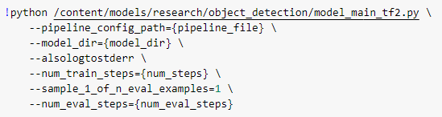

Figure 26 Model training code snippet

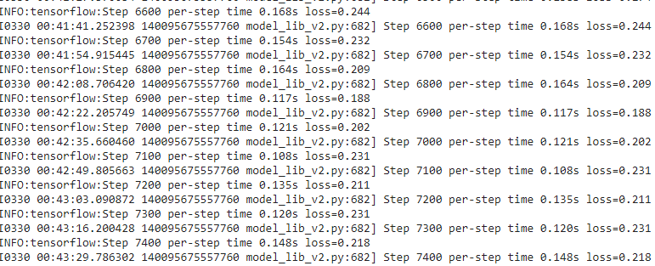

Figure 27 Model training progress

In figure 24, the code to initiate the training can be seen. The code is simple because all the configurations have already been done in a text file from the sections before this. Figure 25 shows the model training progress. Only one version of configurations and model training is shown here for simplicity but different parameters and datasets have been attempted to find a model that fits the project’s scope best.

### 5.4.4 Exporting the Model

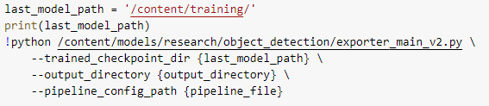

Figure 28 Export model code

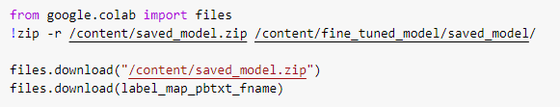

Figure 29 Downloading model to device

Last but not least is exporting the model as seen in figure 26 and then downloading it to the local device following figure 27.

## 5.4 Creating the Application

### 5.4.1 Designing the GUI

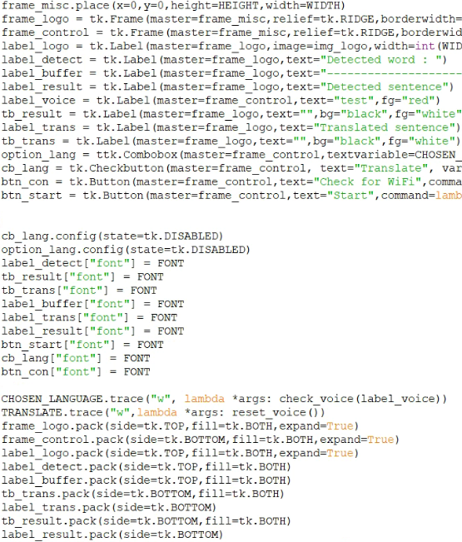

Figure 30 GUI code snippet

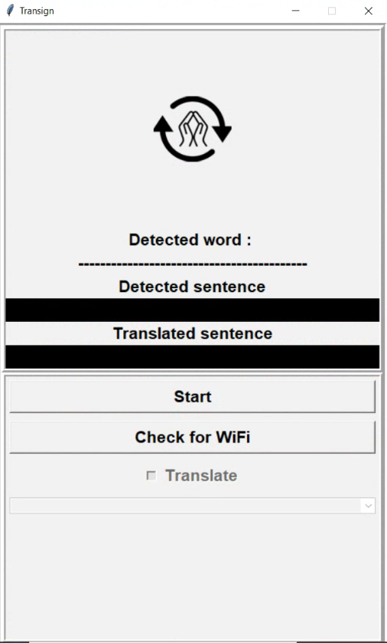

Figure 31 Transign GUI

The GUI for the application was designed with Tkinter, a python library for drawing graphical elements. In figure 28, a snippet of the GUI code can be seen followed by how the complete product looks in figure 29.

### 5.4.2 Sending Data for Predictions

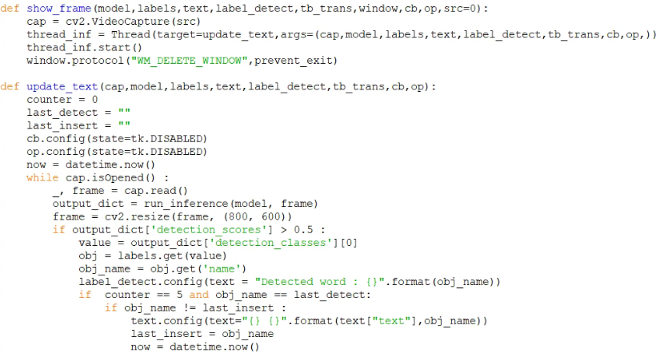

Figure 32 Camera reading snippet

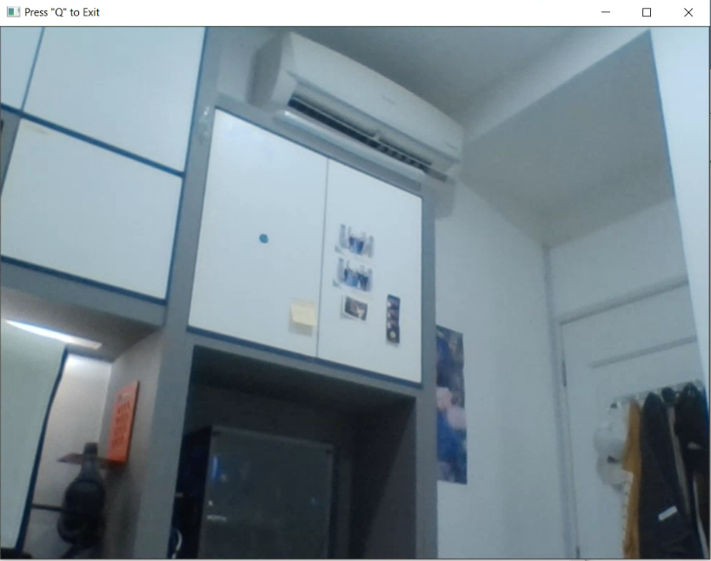

Figure 33 OpenCV Window

In figure 30, a snippet of code to start the camera and read the frames can be seen. The show_frame function initializes the camera and then passes the object over to update_text where tasks such as inference, updating text graphics, and calling the speech synthesizer will be done. Figure 31 shows what the OpenCV window looks like to the user.

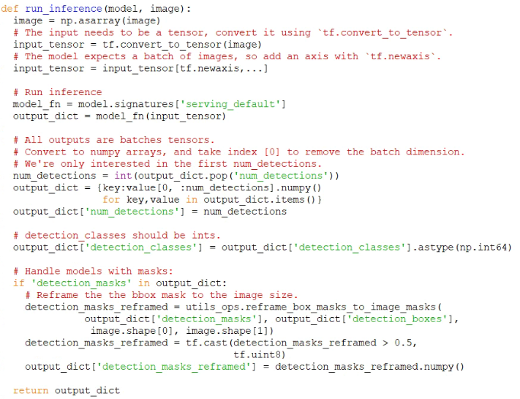

Figure 34 Inference code snippet

The frames read from the camera are passed to the function shown in figure 32. The function run_inference converts the frames into a 2d array and then converts it into tensors which is the input parameters of the model for predictions. The model will then output a dictionary of values, the key ones being the detected class, confidence, and their locations on the inferenced frame.

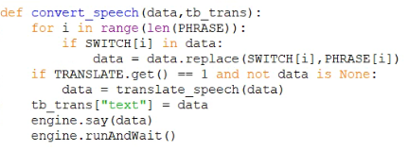

Figure 35 Speech code snippet

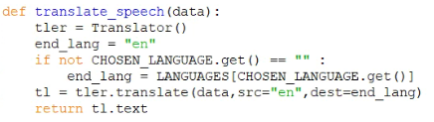

Figure 36 Translation code snippet

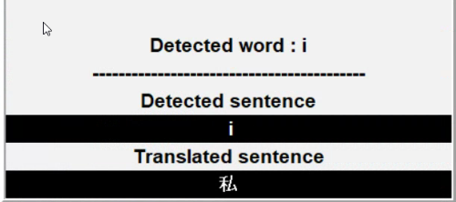

Figure 37 Displayed text

Once the predictions have been completed, the data will be sent over to the convert_speech function to be synthesized into a speech. If the user has the translation option enabled, the data will then again be passed over to translate_speech to obtain the translation in the user’s choice before it gets synthesized. In figure 35, the results of the detection and translation can be seen.

### 5.4.3 Enabling translation

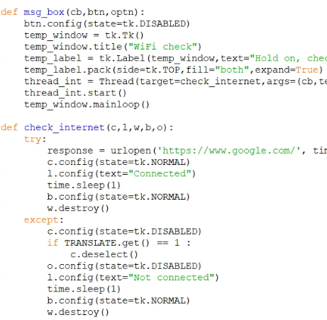

Figure 38 Internet check code snippet

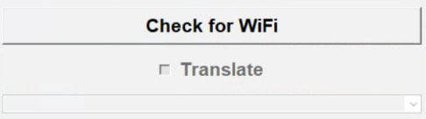

Figure 39 Disabled translation option

Figure 36 shows a snippet of the code to check for internet access. If internet access has not been confirmed, the translation options will be greyed out and the user cannot interact with the widgets as seen in figure 37.

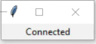

Figure 40 Message box for Internet access

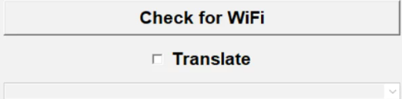

Figure 41 Enabled translation option

Figure 38 shows the message box created by the msg_box function. If the user has choppy connection to wifi, the message box would instead display another message saying “checking for internet connection” for 10 seconds before the functions deems the attempt at connecting a failure. At that time, a different failure message will be displayed instead. If internet access has been confirmed, the widgets for translation would be enabled and interactive with the user.

# Chapter 6: Testing

## 6.1 Overview

In this chapter, the overall testing done for Transign will be discussed. This is to evaluate the application based on the specified requirements. In this project, several testing methods were used to justify the quality of the product for end user to use it without any issues. Moreover, test plans and test results will be discussed under this chapter.

## 6.2 Black Box Testing

The first method that will be used for testing is called black box testing. Black Box Testing is a testing technique that tests the functionality of the Application Under Test (AUT) without seeing the internal code structure, knowledge of internal paths of the software and also implementation details (Nidhra, 2012). This type of testing is based on software specifications and requirements. In general, this testing will only focus on input and output of the software system without the internal knowledge of the software. Firstly, the specifications and requirements of the system are checked. Then, a tester chooses input that is valid and also few invalid inputs to check whether the system can detect them. Then the tester will write down the expected outputs for said inputs. The test cases will then be executed and the output produced will be compared to the expected output. Defects detected will then be fixed and re-tested after (Nidhra, 2012). An example of the black box testing can be seen in the table below while the rest will be within the appendix.

Table 2 Black Box Test Case 1

|  |  |
| --- | --- |
| **Test Case** | 1 |
| **Test Case Description** | Predict the “Hello” hand sign correctly and nothing else. |
| **Input Data** | Webcam stream |
| **Pre-conditions** | - |
| **Expected Output** | “Hello” is predicted with high confidence |
| **Procedures** | 1. Start the application with GUI.py  2. Start the webcam  3. Sign “Hello” |
| **Screenshot of produced output** |  |
| **Post-condition** | The correct hand sign and location is outputted. |
| **Test Result** | Passed |

## 6.3 White Box Testing

The next testing method used is white box testing technique. The white box testing technique tests a software’s internal structure, coding and design. For this kind of testing, code snippets can be seen by the tester (Anon., 2017). The tests will be carried out by a developer knowledgeable regarding the system. The first step that must be taken by the tester is to understand the functionality of the system after observing its source code. After that, the tester has to create the test cases and then execute them. An example test case can be seen in the table below while the rest will be attached in the appendix.

Table 3 White Box Test Case 1

|  |  |
| --- | --- |
| **Test Number: 1** | **Function Name:** check_internet() |
| **Parameters Taken:** cb_trans | |
| **Test Case Description:** allow translation option after internet access is verified | |
| **Expected Result:** translation widget is enabled | |
| **Pre-condition:** Internet access is present | |
| **Test Execution Steps:**  1. Ping Google’s server  2. Wait for response  3. Enable widget based on response | |
| **Post-conditions:** Translation widget is interactive | |
| **Test Result:** Passed | |

## 6.4 Model Evaluation

For the evaluation of the custom trained object detection model’s performance, the COCO mean Average Precision (mAP) metric. The COCO mAP metric has been the preferred method of displaying a model’s performance in recent trends of research papers so this report will also use the COCO mAP metric (Hui, 2018). The COCO mAP metric is based off the COCO mAP, where a 101-point interpolated AP definition is used for the calculation. The COCO mAP metric has a factors to calculate the performance, Intersection over Union (IoU), Average Precision (AP), and Average Recall (AR). IoU is the overlap between the predicted boundary of the model and the real object boundary. AP is an average value of each prediction’s accuracy while AR is the averaged value of positive cases found compared to total number of possible positive cases (Anon., 2019). Tensorflow’s Object Detection API comes with evaluation tools and the results of the evaluation on said model can be seen in the figure below.

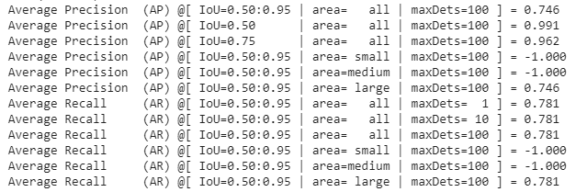

Figure 42 Evaluation metrics

The area column has results displaying -1 due to the purpose the model was trained for. Some models trained for object detection targeted small objects such as detecting different color pieces of corn on a cob which is small in size in comparison to this model’s purpose of detecting hand signs which take up a significant amount of space within a frame at any time.

# Chapter 7: Evaluation

## 7.1 Overview

This chapter discusses about the functionalities of the application by evaluating the features and also the process to complete the product. This chapter will also explain the idea on the application’s overall description and the process went through by the developer to develop this end to end deep learning for self-driving vehicles.

## 7.2 Product Evaluation

The detailed evaluation of product was done after the implementation and testing phase of the system. Strengths and weaknesses of the system based on the functionality will be discussed in product evaluation.

### 7.2.1 Product Functionality

The main objective of this application is to take in real time video feed of a person performing hand signs and converting it to speech through a mobile application which has been mostly achieved. The reason why the term “mostly” is used is due to the problem of implementing the idea on a mobile platform which will be explained more later on in problems faced. Moving on, the application produced achieves the objective by first presenting a user-friendly GUI for the user to start the camera stream. Once the camera stream is started, the user is free to perform the hand signs and this can be further confirmed by the user through the frame that shows up on the screen in 800x600 pixel resolution for resource efficiency as explained in the previous chapters.

The frames are then sent in real time to the model where predictions will be made on what hand signs are being made by the user. Not only that, the user can also see whether the meaning they want to convey is correctly predicted by the model as the sentence is built and shown in real time on the GUI.

Once the predictions have been made and the text has been displayed on the GUI, the output will be sent to the speech synthesizer to be voiced in an English speaking voice or another language if the translation option was enabled. The user will first have to tell the GUI to check for Internet connection first for the translation option to be enabled. Not only that, the user has to install the Windows speech pack in the language they wish to translate and voice the hand signs they perform. A warning message will be displayed to the user if the language they chose does not have a speech pack installed locally but the application will still function and display the translated text but only voice the English text version of the hand signs.

### 7.2.2 Strengths and Weaknesses

One of the strengths of the application is that it can be mostly run offline. The application does not need Internet access if the translation option is not needed which fulfills its core role of helping mute or deaf people communicate in sign language to its relative spoken language. Besides that, the application does not need a super computer to run and can be run as long as a speaker and camera is present with the device. Moving on, no data is of the user is stored anywhere locally or online as facial data is a sensitive intellectual property that has no right being exposed or stored.

Despite that, the system also has its weaknesses. The accuracy of the model is currently good in targeted situations only due to the lacking data repositories of different people performing different hand signs in different environments which is too severe to be solved by just data augmentation. All data used in the application thus far is created by the developer alone which makes this application more of a proof-of-concept right now.

### 7.2.3 Mobile Implementation

A special section is required to explain the above topic. The initial proposal was to have the application function within a mobile device running the Android operating system. During the analysis phase, the idea was research on and deemed feasible with the number of examples found in public sources. The neural network was to be implemented using TFLite and ran locally in real time. With that said, the implementation was a failure with the reason unknown. The model was retrained multiple times with different datasets and parameters, performed as expected when run on a non-mobile device but performed drastically worse, to the point that it was unusable, when converted to TFLite format on mobile. Even after much troubleshooting and discussion on online platforms, the problem was not solved. The decision to convert to an implementation with Python was made when problem of the deadline nearing came up.

## 7.3 Process Evaluation

In this sub chapter, the process and phases in development of AutoMove will be discussed based on the project plan created during the writing of the proposal and then reviewed on its execution. The planned durations can be found in the Gantt Chart of the Appendix.

### 7.3.1 Initiation Phase

Table 4 Initiation Review

|  |  |  |  |
| --- | --- | --- | --- |
| Initiation Phase | Start Date | End Date | Duration (Days) |
| Project Plan | 14-09-2020 | 02-10-2020 | 19 |
| Actual Progress | 14-09-2020 | 28-09-2020 | 14 |

During the initiation phase, project ideas were short listed and discussed based on their feasibility and practicality with the supervisor. An appropriate idea and title were then chosen followed by appropriate research on the topic. Lastly, the project initiation document (PID) is prepared and submitted after reviews from the supervisor.

### 7.3.2 Planning Phase

Table 5 Planning Review

|  |  |  |  |
| --- | --- | --- | --- |
| Planning Phase | Start Date | End Date | Duration (Days) |
| Project Plan | 03-10-2020 | 27-11-2020 | 56 |
| Actual Progress | 03-10-2020 | 20-11-2020 | 50 |

Planning phase is a particularly important phase for the development of this project. Neural networks and machine learning is still a relatively new technology recently commercialized for everyday use by society. Due to this, there is only so much research and papers on the specific subtopic that this project is looking for. During this phase, articles and papers were constantly brought up and discussed with the supervisor to discuss its relevancy to this project’s topic. After that, the project proposal draft was written and then submitted to the supervisor and second marker. The second marker and supervisor would return this draft after reviewing it and then changed based on the feedback. The proposal is then submitted a few days earlier as extensive research and discussion was already done before the review so only basic changes were required. One thing of note is the start date of the planning phase is the same as planned despite the early finish on the initiation phase due to the need to focus on core subjects during the semester.

### 7.3.3 Analysis Phase

Table 6 Analysis Review

|  |  |  |  |
| --- | --- | --- | --- |
| Analysis Phase | Start Date | End Date | Duration (Days) |
| Project Plan | 01-12-2020 | 05-12-2020 | 5 |
| Actual Progress | 27-11-2020 | 05-12-2020 | 9 |

Similar to the planning phase, the start date is only a little earlier than the planned start date due to settling other assignments. Despite starting earlier, the analysis phase took longer than planned due to the under estimation of the difficulty of implementing the idea. The analysis phase began with research on how Tensorflow functioned, then on the different model architectures that existed and how they functioned with Tensorflow. After that, journals and articles related to object detection, human limbs recognition, and hand sign recognition were studied to determine the order of implementation. As explained in the literature review phase, CNN was chosen as the neural network with SSD algorithm to accompany it. The UML diagram, sequence diagram, and functional requirements were quickly done after the literature review was completed and had no problems that required it to be changed.

### 7.3.4 Implementation Phase

Table 7 Implementation Review

|  |  |  |  |
| --- | --- | --- | --- |
| Implementation Phase | Start Date | End Date | Duration (Days) |
| Project Plan | 10-12-2020 | 15-01-2021 | 39 |
| Actual Progress | 05-12-2020 | 20-01-2020 | 49 |

The implementation phase started right after the analysis phase as the difficulty of the project was realized during that time coupled together with the developer’s inexperience with any practical implementations related to machine learning. The duration was also longer due to the problem with the mobile implementation as explained in the testing section of this report. Other than that, the application was implemented in the order of the functional, non-functional requirements and UML diagrams created. Most of the time used was gathering custom data for training and experimenting with different augmentations, parameters, and datasets to train the model. If the developer had more experience with machine learning prior to this project, the time taken for this phase could have been shaved down.

### 7.3.5 Testing Phase

Table 8 Testing Review

|  |  |  |  |
| --- | --- | --- | --- |
| Testing Phase | Start Date | End Date | Duration (Days) |
| Project Plan | 10-01-2021 | 24-01-2021 | 15 |
| Actual Progress | 15-01-2021 | 24-01-2021 | 10 |

Initially, the testing phase was planned to be from the 10th of January to 24th January, done in tandem with the implementation phase as the prototyping methodology was used. Due to the difficulty of the implementation, the testing phase was cut short to a 10 day duration instead of the planned 15. Luckily, no problems were met during the testing and documenting so the planned end date was met.

### 7.3.6 Documentation Phase

Table Documentation Review

|  |  |  |  |
| --- | --- | --- | --- |
| Documentation Phase | Start Date | End Date | Duration (Days) |
| Project Plan | 24-01-2021 | 09-02-2021 | 17 |
| Actual Progress | 24-01-2021 | 09-02-2021 | 17 |

The last phase is the documentation phase, although documentation was to be done during this duration, bits and pieces were already written as the project was done during design and implementation so the rest of the report was written without a hitch in time. The draft was then sent to the supervisor for review and changes were then made accordingly.

# Chapter 8: Conclusion and Recommendation

## 8.1 Conclusion

Transign is a deep-learning sign language-to-speech translation application that can convert American Sign Language to English and many other languages in real time. The backbone of this application is a model created following the CNN architecture using the SSD algorithm to perform real time object detection and classification.

This system was developed in hopes that deaf or mute people can have an easier way of communication with common people when common means such as writing text on a notepad or phone for people to read is not possible. According to the World Federation of the Deaf in 2020, there are approximately 72 million deaf people worldwide and using sign language. That population is only 1% of the world’s population which makes sign language a rare skill found among the world’s people. Not only that, sign language consists of 300+ different languages similar to the spoken languages of the world (Deaf, 2020). Transign hopes to help bridge the gap with technology so that communication is all the more accessible for deaf or mute people within the world.

## 8.2 Recommendation

Transign is closer to a proof of concept as said in the product evaluation and has many areas where it can definitely be improved on. The recommendations will be split into two sections, improvements on existing features and new features that can be implemented.

In existing features, the speech pack’s installation can be automated instead of requiring the user to manually install the speech packs. This can be done by doing more research on how Windows speech packs are installed and how registry keys are written and edited with code. Besides that, the model’s accuracy can be improved to be accurate in any situation or environment with the injection of larger quantities of data from different people around the world. A sharing platform could be setup to gather data from volunteers so that a variety of sign languages, ethnics, lighting, and backgrounds can be generated for the model to be trained. Not only that, this sharing platform could help the developer create different models that will be able to recognize different sign languages based on the user’s choice.

For new features, mobile implementation is still on the board but requires more research since the initial research underestimated the required time, work, and experimentation to bring this feature to life. Another new feature is splitting the model’s work into two phases. The first phase would have the object detection model detect the hands of the user, box it, and then snap the picture of the box. The picture would then be classified by an image classification model instead which would definitely provide higher accuracy, easier model training, and reduce the load on processing power required on the model.

# References

Anon., 2017. White Box Testing with Object Oriented programming. *International Journal of Recent Trends in Engineering and Research,* 3(11), pp. 156-160.

Anon., 2019. Evaluation and Evolution of Object Detection Techniques YOLO and R-CNN. *International Journal of Recent Technology and Engineering,* Volume 8, pp. 824-829.

Deaf, W. F. o., 2020. *WFD Statement on Standardized Sign Language.* [Online]   
Available at: https://wfdeaf.org/news/wfd-statement-on-standardized-sign-language/  
[Accessed 11 April 2021].

Developers, A., n.d. *How single-shot detector (SSD) works?.* [Online]   
Available at: https://developers.arcgis.com/python/guide/how-ssd-works/#:~:text=Instead%20of%20using%20sliding%20window,an%20object%20within%20that%20region.  
[Accessed 05 April 2021].

Hui, J., 2018. *Medium.* [Online]   
Available at: https://jonathan-hui.medium.com/map-mean-average-precision-for-object-detection-45c121a31173  
[Accessed 04 April 2021].

Morera, A. et al., 2020. *SSD vs. YOLO for Detection of Outdoor Urban Advertising Panels under Multiple Variabilities,* s.l.: s.n.

Nidhra, S., 2012. Black Box and White Box Testing Techniques - A Literature Review. *International Journal of Embedded Systems and Applications,* 2(2), pp. 29-50.

O'Shea, K. & Nash, R., 2015. *An Introduction to Convolutional Neural Networks,* s.l.: s.n.

YANG, C.-C.et al., 2000. *Application of artificial neural networks in image recognition and classification of crop and weeds,* Ste-Anne-de-Bellevue, QC, Canada : McGill University.

What is a smartphone? | Digital Unite (no date). Available at:

https://www.digitalunite.com/technology-guides/smartphonestablets/smartphones/what-smartphone (Accessed: 3 November 2020).

Mobile Operating System Market Share Worldwide | StatCounter Global Stats (no

date). Available at: https://gs.statcounter.com/os-market-share/mobile/worldwide (Accessed: 3 November 2020).

Young, I. et al. (2004) ‘Fundamentals Of Image Processing’.

da Silva, E. A. B. and Mendonça, G. V. (2005) ‘4 - Digital Image Processing’, in

Chen, W.-K. (ed.) The Electrical Engineering Handbook. Burlington: Academic

Press, pp. 891–910. doi: 10.1016/B978-012170960-0/50064-5.

Shalev-Shwartz, S. and Ben-David, S. (2014) Understanding Machine Learning:

From Theory to Algorithms. Cambridge: Cambridge University Press. doi:

10.1017/CBO9781107298019.

Decencière, E. et al. (2013) ‘TeleOphta: Machine learning and image processing

methods for teleophthalmology’, IRBM, 34(2), pp. 196–203. doi:

10.1016/j.irbm.2013.01.010.

Socher, R., Bengio, Y. and Manning, C. D. (2012) ‘Deep learning for NLP (without

magic)’, in Tutorial Abstracts of ACL 2012. USA: Association for Computational

Linguistics (ACL ’12), p. 5.

Perez, L. and Wang, J. (2017) ‘The Effectiveness of Data Augmentation in Image

Classification using Deep Learning’, arXiv:1712.04621 [cs]. Available at:

http://arxiv.org/abs/1712.04621 (Accessed: 3 November 2020).

Chadalawada, S. K. (no date) ‘Real Time Object Detection and Recognition’, p. 66.

Gavrila, D. M. and Philomin, V. (1999) ‘Real-time object detection for “smart”

vehicles’, in Proceedings of the Seventh IEEE International Conference on Computer

Vision. Proceedings of the Seventh IEEE International Conference on Computer

Vision, pp. 87–93 vol.1. doi: 10.1109/ICCV.1999.791202.

Al-Husseini, K. and Obaid, A. (2018) ‘USAGE OF PROTOTYPING IN SOFTWARE

TESTING’, 14, pp. 1–10.

Carr, M. (1998) Prototyping and Software Development Approaches, undefined.

Available at: /paper/Prototyping-and-Software-Development-ApproachesCarr/0b05add730e04843e234937a070f24b19efaadc3 (Accessed: 21 November

2020).

‘SDLC - Software Prototype Model’ (no date), p. 3.

Kotlin and Android | Android Developers (no date). Available at:

https://developer.android.com/kotlin (Accessed: 21 November 2020).

Interpret Sign Language with Deep Learning (no date). Available at:

https://kaggle.com/paultimothymooney/interpret-sign-language-with-deep-learning

(Accessed: 21 November 2020).

Jalled, F. (2017) Face Recognition Machine Vision System Using Eigenfaces.

Available from https://arxiv.org/abs/1705.02782 [accessed 3 April 2021].

Wagh, P., Thakare, R., Chaudhari, J. and Patil, S. (2015) Attendance system based on

face recognition using eigen face and PCA algorithms. 2015 International Conference

on Green Computing and Internet of Things (ICGCIoT)

Sermanet, P., Eigen, D., Zhang, X. and Mathieu, M. (2013) OverFeat: Integrated

Recognition, Localization and Detection using Convolutional Networks. Available

from https://arxiv.org/abs/1312.6229 [accessed 3 April 2021].

Redmon, J., Divvala, S., Girshick, R. and Farhadi, A. (2016) You Only Look Once:

Unified, Real-Time Object Detection 1-4.

|  |  |
| --- | --- |
| **Test Case** | Black box |
| **Test Case Description** |  |
| **Input Data** |  |
| **Pre-conditions** |  |
| **Exepected Output** |  |
| **Procedures** |  |
| **Screenshot of produced output** |  |
| **Post-condition** |  |
| **Test Result** |  |